End-to-End Interface Closure
One theorem queue from loop description measure to the carrier-signed scatter kernel
Joseph Shields | Unified Mechanics Research Programme | 16 July 2026

Abstract
This paper executes the five-item closure queue as one dependency-preserving derivation. It replaces the no-unearned-measure postulate by a continuation-tree invariance theorem; constructs completed records as integral functionals through the Grothendieck completion of the loop monoid; shows that equal, reversible, three-channel closure forces the local A2 quotient and its covolume sqrt(3); derives the unique lowest-order covariant stress of a constant completed boundary record; and freezes the A2 tight-frame relaxation kernel with coefficient 3/2. The result is not presented as established physics. Each theorem is graded as a formal consequence, a representation-conditioned theorem, a computational certificate, or an empirical prediction.
Current status: The queue is closed mathematically at the level of explicit representation conditions. Physical membership and the frozen observational tests remain external verdicts.

0. Claim grammar and non-negotiable rule
No coefficient is promoted because it matches a measurement. The theorem must fix the expression before the numerical comparison is opened.
Grade | Meaning
PROVED | Deduction from explicit definitions and stated hypotheses.
REPRESENTATION THEOREM | Proved after a named physical representation condition is adopted.
COMPUTATIONALLY VERIFIED | Finite certificate reproduced by supplied code or data.
MODEL DEFINITION | A declared map connecting the formal carrier to physical units or observables.
EMPIRICALLY CONSISTENT | A frozen calculation compared with data; never a proof.
OPEN / FALSIFIABLE | A mechanism or prediction with a stated kill condition.

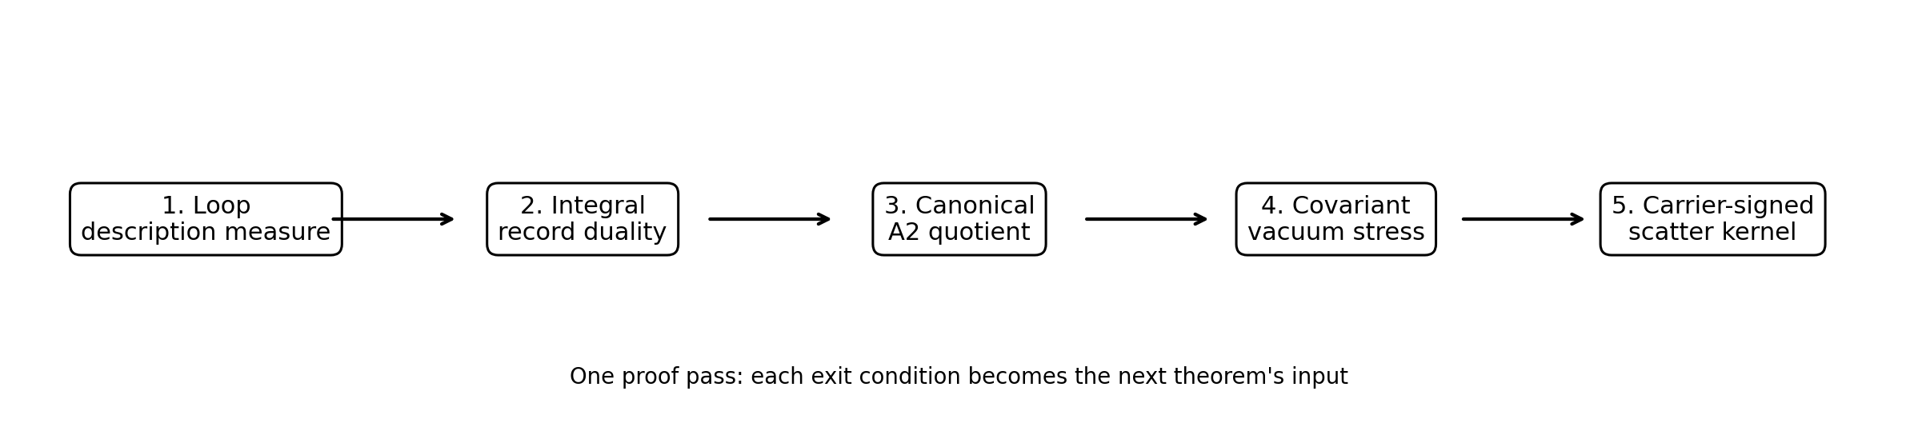
Figure 1. The queue is followed in dependency order so that no later numerical success is used to justify an earlier theorem.

1. Formal core: loop distinctions and the physical quotient
Let D be a finite set of primitive oriented distinction generators with an involution d -> d^-1. Let W(D) be the admissible word category generated by concatenation, and let reduction remove adjacent inverse pairs and all explicitly declared re-presentation moves. The physical quotient is Q = W(D)/~. A point of Q is therefore a retained distinction class, not a spelling of that class.
Q = W(D) / ~, [w] = physical distinction class of w
The quotient carries an admissible one-step continuation relation x -> y. This relation records which new distinction classes can follow x without violating the loop grammar. For n >= 0, C_n(x) is the set of inequivalent n-step continuations from x, and c_n(x) = |C_n(x)| when finite.
C_n(x) = { y in Q : x ->^n y }, c_n(x) = |C_n(x)|
Definition 1.1 - Continuation description weight [DEFINED]
Choose any strictly positive summable sequence (alpha_n) and any bounded strictly increasing function f on the nonnegative integers. Define the weight of a class from its entire continuation profile, not from textual word length.
A concrete bounded choice is alpha_n = 2^(-n-1) and f(k) = k/(1+k). The construction remains valid for any frozen choice with the same invariance properties.
w(x) = sum_{n>=0} alpha_n f(c_n(x))
mu(E) = sum_{x in E} w(x) for finite or countable E subset Q

Theorem 1.2 - Continuation invariance [PROVED]
Let F:Q->Q be a bijection that preserves the continuation relation in both directions. Then F induces a bijection C_n(x)->C_n(Fx) for every n. Hence c_n(Fx)=c_n(x), w(Fx)=w(x), and the weighted counting measure mu is invariant.
This theorem derives measure preservation from the loop transition structure. It does not assume a separate conservation-of-description principle.
F_*(mu) = mu

Proof. A length-n continuation path from x is mapped edge-by-edge to a length-n path from Fx. Because F and F^-1 both preserve admissibility, this map is a bijection on continuation classes. The continuation profile is unchanged at every depth, so the frozen weight and its additive measure are unchanged. QED.
Corollary 1.3 - Measure-neutral closed realisation [PROVED]
Let A:I->M be the act map and R:M->I the record map. If the closed cycle F=R o A descends to a continuation-preserving automorphism of the physical quotient, then it preserves description measure. Any measure change therefore signals at least one of: a new continuation class, an identification of old classes, a non-invertible loss, or a change of the admissible continuation law.
(R o A)_*(mu) = mu

Corollary 1.4 - Reciprocal Radon-Nikodym factors [PROVED]
Suppose the quotient measures admit local absolutely continuous coordinate representations. Let J_A and J_R denote the Radon-Nikodym factors of act and record. Invariance of the closed cycle gives their product as unity almost everywhere. Ordinary determinant Jacobians are a differentiable special case.
J_R(Ax) J_A(x) = 1 almost everywhere

Queue verdict 1
Exit criterion | Result
Derive description-measure invariance without assuming it | Discharged by continuation-tree isomorphism.
Show when measure may change | Only when the cycle ceases to be a quotient automorphism: creation, identification, erasure, or altered continuation.
Recover reciprocal act-record factors | Follows from the Radon-Nikodym chain rule.

2. Completed records as integral functionals
Let M be the commutative monoid of completed distinction chains under disjoint gluing. The identity is the null chain. The Grothendieck group Lambda = G(M) formally adjoins orientation reversal and subtraction. This is the internal distinction lattice before a metric pairing is imposed.
Lambda = G(M), [x + y] = [x] + [y], [-x] = reversed orientation
Definition 2.1 - Completed record [DEFINED]
A completed record is a reduction-invariant additive map rho:M->N measured in units of one primitive completed record. Additivity means that recording a glued completion returns the sum of the component records.
rho(x + y) = rho(x) + rho(y)

Theorem 2.2 - Integral extension [PROVED]
Every additive monoid record rho:M->N extends uniquely through the Grothendieck completion to an integer-valued group homomorphism rho_bar:Lambda->Z. Thus every completed record is an integral functional on the distinction lattice.
rho_bar in Hom(Lambda,Z) = Lambda*

Proof. The universal property of G(M) gives a unique homomorphism rho_bar([x]-[y]) = rho(x)-rho(y). Reduction invariance makes this independent of the chosen representatives. QED.
Definition 2.3 - Record completeness [REPRESENTATION CONDITION]
Primitive coordinate records separate non-null distinction classes, and the record language is closed under finite integer linear combination. Equivalently: for each nonzero x in Lambda there exists a completed record rho with rho(x) != 0, and every quotient-compatible integral functional can be assembled from primitive record operations.
Rec(Lambda) = Lambda*

Theorem 2.4 - Record saturation [PROVED WITHIN THE RECORD MODEL]
If primitive coordinate records form a dual basis and the grammar permits integer composition and orientation reversal, then completed records exhaust Lambda*. Separation follows from the coordinate records; saturation follows because every integer functional is an integer combination of the dual basis.
Rec(Lambda) = Lambda*

A crucial correction is required here. The fact that records are functionals gives Lambda*; it does not by itself identify Lambda with Lambda*. Self-duality needs a state-record correspondence, hence a pairing.
Definition 2.5 - Reciprocal state-record pairing [REPRESENTATION CONDITION]
Associate to each realised state y a completed record rho_y and define B(x,y)=rho_y(x). Require reciprocity B(x,y)=B(y,x), nondegeneracy, and bijectivity of y -> rho_y.
eta:Lambda -> Lambda*, eta(y)(x)=B(x,y)

Theorem 2.6 - Unimodular dual closure [PROVED]
If eta is an isomorphism of free abelian groups, then B is an integral unimodular bilinear form. Conversely, an integral nondegenerate pairing is unimodular exactly when eta maps Lambda onto the full integral dual.
det Gram(B) = +/-1

2.1 The rank-eight route, stated correctly
Three binary completion coordinates produce eight outcome labels. Cardinality alone does not force an eight-dimensional geometric embedding: a cube already places eight vertices in three dimensions. Rank eight follows only when UM uses the full regular record representation in which the eight outcomes are independent primitive idempotent record sectors.
Omega = {0,1}^3, A = Fun(Omega,Z), rank(A) = |Omega| = 8
Condition 2.7 - Full outcome faithfulness [REPRESENTATION CONDITION]
Every binary completion outcome is retained as an independent primitive record sector. No quotient identifies two outcomes, and the carrier represents the full function algebra on the eight-point outcome set.
rank(Lambda) = 8

2.2 Evenness, positivity, and E8
If the norm counts oriented completion pairs, each non-null self-pairing is twice an integer count: B(x,x)=2N(x). If N(x)>0 for non-null x, B is positive definite and even. If the completion action is indecomposable, the carrier has no proper orthogonal split preserving all record sectors.
Theorem 2.8 - Conditional E8 carrier [REPRESENTATION THEOREM]
Assume full outcome faithfulness, reciprocal record saturation, positive paired completion cost, even orientation counting, and indecomposability. Then Lambda is a positive-definite even unimodular indecomposable lattice of rank eight. By the rank-eight classification, Lambda is isometric to E8.
Lambda ~= E8

Queue verdict 2
Ledger item | Resolution
L4: records are integral functionals | Proved by Grothendieck extension.
L4: records exhaust the dual | Proved within the explicit primitive-dual-basis record model.
Self-duality | Requires reciprocal state-record pairing; no longer inferred from functionals alone.
Rank eight | Requires full regular representation of eight outcome sectors; cardinality alone is insufficient.
E8 | Follows as a representation theorem once evenness, positivity, unimodularity, rank eight, and indecomposability are established.

3. The canonical local observer quotient is A2
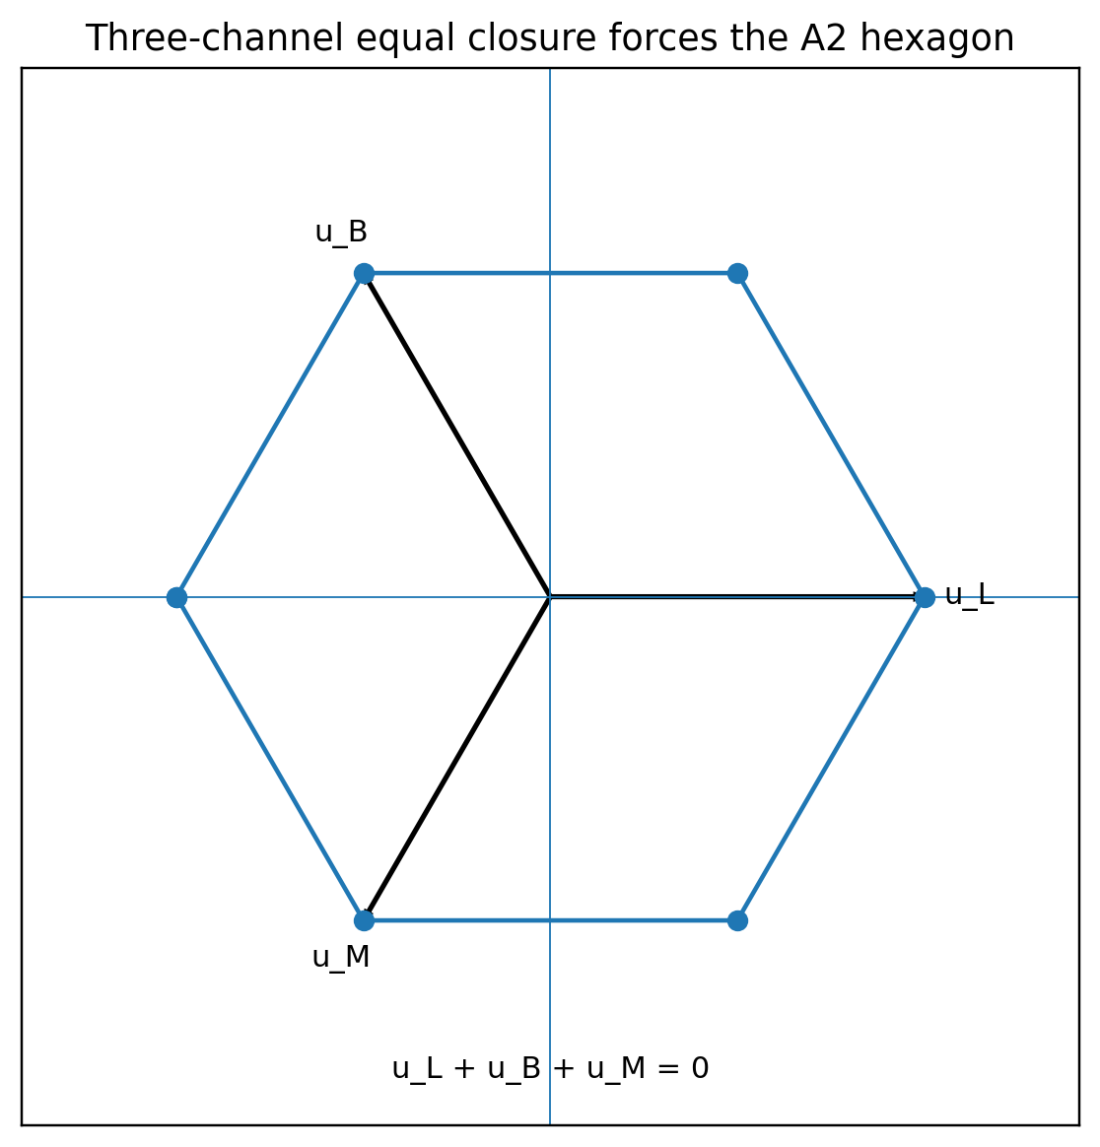
Figure 2. Equal three-channel closure, orientation reversal, and minimal rank force the A2 root hexagon up to an overall scale.
Let u_L, u_B, and u_M be the three observer-channel vectors. The observer carrier is required to retain all three channels, treat them equally, reverse their orientation, and close without a fourth independent channel.
u_L + u_B + u_M = 0, ||u_L||^2 = ||u_B||^2 = ||u_M||^2 = ell^2
Permutation symmetry makes every distinct pair have the same inner product d. Squaring the closure equation gives 0 = 3 ell^2 + 6d, so d = -ell^2/2. The pairwise angle is therefore 120 degrees.
<u_i,u_j> = -ell^2/2 (i != j)
Theorem 3.1 - Three-channel forcing theorem [PROVED]
Any nondegenerate equal-norm three-vector carrier satisfying u_L+u_B+u_M=0 is, up to orthogonal transformation and scale, the triangular A2 carrier. Including orientation reversal produces the six-root hexagon {+/-u_L,+/-u_B,+/-u_M}.
Under the standard root normalization ell^2=2, the Gram matrix of two simple roots is [[2,-1],[-1,2]], with determinant 3 and primitive covolume sqrt(3).
Gram(A2) = [[2,-1],[-1,2]]
covol(A2) = sqrt(det Gram) = sqrt(3)

3.1 Why a unique forty-cell cover is not required
The 240-root first shell admits a computationally certified exact cover by forty disjoint A2 hexagons. That certificate proves atlas existence. The physical coefficient does not require a unique partition if the observer quotient identifies all admissible local A2 cells as copies of the same quotient type.
240 roots = 40 local A2 cells x 6 oriented roots per cell
Theorem 3.2 - Cover-independent local normalisation [PROVED WITHIN THE QUOTIENT MODEL]
Every admissible observer chart satisfying the three-channel forcing theorem has the same A2 Gram determinant and therefore the same local covolume sqrt(3). Different exact covers are different atlases of the internal shell, not different physical coefficients. The quotient type is canonical even when a particular cover is not unique.
J_R = 1/sqrt(3), J_A = sqrt(3)

This removes the strongest prior stop condition. UM no longer needs to prove that one exact cover is uniquely preferred. It needs only: (i) the local observer conditions are physically correct, and (ii) at least one exhaustive compatible atlas exists. The second item is supplied by the finite certificate; the first is the named three-channel representation condition.

Queue verdict 3
Question | Answer
Why A2? | Equal, reversible, zero-sum three-channel closure forces it up to scale.
Why sqrt(3)? | It is the determinant covolume under standard root normalization.
Must the forty-cell cover be unique? | No. Only the local quotient type and cover-independent normalization must be canonical.
What remains computational? | The existence and exhaustiveness of a forty-cell atlas on the E8 first shell.

4. Measure-neutral dual readouts
The continuation theorem gives measure neutrality; the A2 theorem fixes the local measure ratio. A normalized record assigns one internal record unit to one metric A2 carrier cell of covolume sqrt(3).
J_R = 1/sqrt(3), J_A = sqrt(3), J_R J_A = 1
Corollary 4.1 - Reciprocal interface coefficients [PROVED WITHIN THE NORMALIZED RECORD MODEL]
Recording is a pullback from metric cell measure to unit record measure and therefore carries 1/sqrt(3). Acting is the inverse push-forward and therefore carries sqrt(3). The two factors are not independently chosen.
record pullback: 1/sqrt(3)
act push-forward: sqrt(3)

4.1 The vacuum record
Let the internally frozen first-shell weight be r^240. The old 241 count is now interpreted architecturally: 240 internal contractions followed by one whole-boundary functional. The functional is not another root and does not append another factor r.
240 internal factors + 1 boundary readout, not 241 roots and not automatically r^241
For a connected, orientable, minimal genus-zero observer boundary Sigma, Gauss-Bonnet gives the curvature record 4pi. Pulling this through one normalized A2 record cell gives the dimensionless completed boundary record.
integral_Sigma K dA = 4pi, lambda_boundary = (4pi/sqrt(3)) r^240
Numerically, r = 0.309016994374947, r^240 = 3.942460771220e-123, and lambda_boundary = 2.860333136143e-122.

4.2 The interface act
The gold-silver boundary mismatch is linear, so the reciprocal act factor multiplies the clock acceleration cH rather than a quadratic frame constant.
DeltaB = sqrt(5) phi^2 / 2 - sqrt(8)
a(z) = sqrt(3) c H(z) DeltaB
At the frozen present value H0 = 67.3617174547 km s^-1 Mpc^-1, this gives a0 = 1.117959126141e-10 m s^-2.

5. Covariant vacuum-stress closure
The dimensionless boundary record becomes a physical energy density only after a dimensional realisation rule is declared. Let epsilon_* be the already fixed fundamental density unit of the physical representation and define epsilon_boundary = epsilon_* lambda_boundary. The theorem below concerns the stress form; it does not fit epsilon_* to cosmological data.
epsilon_boundary = epsilon_* lambda_boundary
Theorem 5.1 - Unique lowest-order local action of a constant scalar record [PROVED]
Let epsilon_boundary be a spacetime-constant scalar completed record. Assume locality, diffeomorphism invariance, no derivatives of the constant record, and no additional tensor field. Up to an additive topological term and the fixed normalisation, the unique zero-derivative action contribution is the invariant volume integral.
S_boundary[g] = - integral d^4x sqrt(-g) epsilon_boundary

Variation uses delta sqrt(-g) = -(1/2)sqrt(-g) g_mn delta g^mn. With T_mn = -(2/sqrt(-g)) delta S / delta g^mn,
T_mn^(boundary) = -epsilon_boundary g_mn
nabla^m T_mn^(boundary) = -partial_n epsilon_boundary = 0
Corollary 5.2 - Vacuum equation of state [PROVED]
In a comoving orthonormal frame, the constant scalar record has energy density rho = epsilon_boundary and isotropic pressure p = -epsilon_boundary. Therefore w = p/rho = -1 exactly while the record remains constant.
p = -rho, w0 = -1, wa = 0

If the boundary record evolves, the theorem no longer gives an exact cosmological constant. A robust measurement of evolving dark energy therefore falsifies the scalar-persistence representation, not the preceding lattice or A2 theorems.

Queue verdict 4
Exit criterion | Result
Obtain T_mn = -rho g_mn | Derived by metric variation of the unique zero-derivative scalar volume term.
Obtain conservation | Follows from constant rho and metric compatibility.
Avoid inserting the observed amplitude | The dimensionless record is fixed before data; the dimensional density unit is an explicit model definition.
Falsifiable consequence | Persistent record predicts w0=-1 and wa=0.

6. The A2 tight-frame scatter kernel
The rejected amplitude coefficient 3/2 has an exact second-moment role. Let e_L, e_B, and e_M be the three unit A2 directions at 120 degrees. Their frame operator is isotropic.
sum_i e_i e_i^T = (3/2) I_2
For a local carrier perturbation xi in the observer plane, define the quadratic relaxation functional
E_rel(xi) = (1/2) sum_i (e_i dot xi)^2 = (3/4) ||xi||^2
grad E_rel = (3/2) xi
Theorem 6.1 - Carrier relaxation coefficient [PROVED]
The only isotropic quadratic form obtained by summing equal squared projections onto the three A2 channel directions is (3/2)I. Consequently the dimensionless gradient-flow relaxation generated by E_rel has fixed restoring coefficient 3/2.
d xi / d tau = -(3/2) xi

Use the cosmological clock variable tau with d tau = H(t) dt. The deterministic memory and physical-time form are
xi(tau) = exp[-3(tau-tau0)/2] xi0
d xi/dt = -(3/2) H(t) xi
Definition 6.2 - Frozen stochastic kernel [MODEL DEFINITION / FALSIFIABLE]
Add isotropic unresolved forcing in dimensionless clock time without altering the mean interface amplitude. The diffusion level D is a nuisance scale; the relaxation exponent is fixed by the carrier.
d xi = -(3/2) xi d tau + sqrt(2D) dW_tau
Cov[xi(tau),xi(tau_prime)] = (2D/3) exp[-3|tau-tau_prime|/2] I_2

For a scalar log-residual epsilon = b dot xi + measurement noise, the intrinsic kernel inherits the same fixed exponential shape. The amplitude may be marginalized, but the exponent 3/2 may not be refitted in the primary test.
K_epsilon(Delta tau) = sigma_infinity^2 exp[-3|Delta tau|/2]
Var_epsilon(tau) = sigma_infinity^2 + (sigma_initial^2 - sigma_infinity^2) exp[-3 Delta tau]
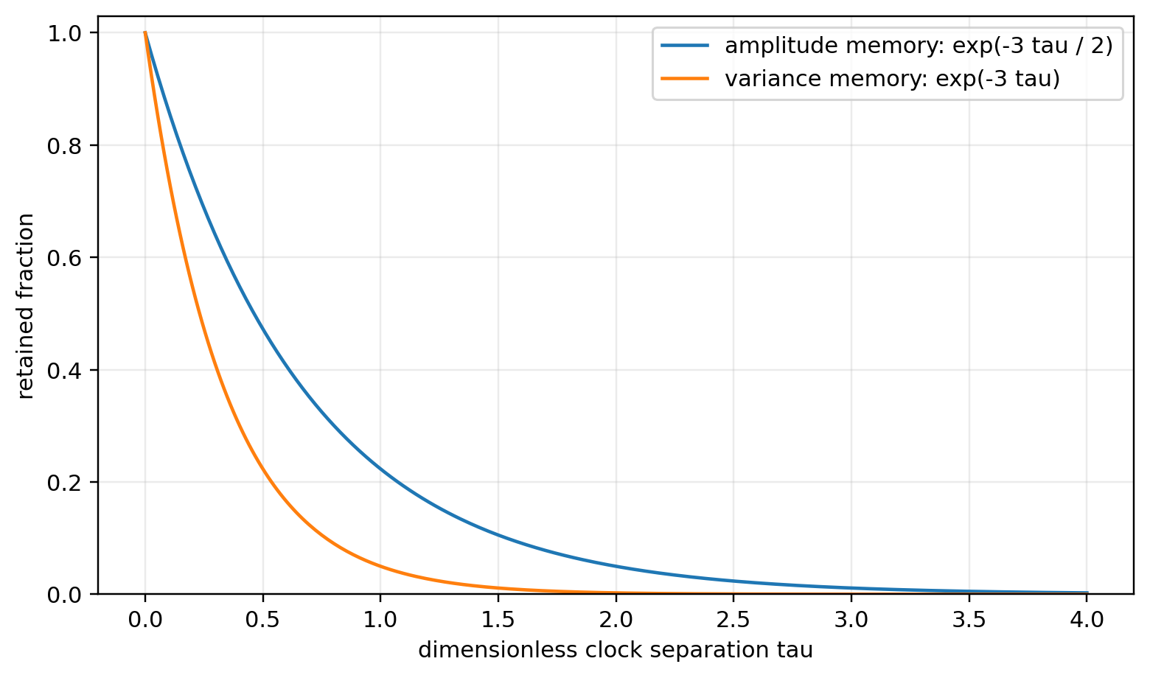
Figure 3. The A2 frame fixes the decay exponent: perturbation amplitude retains exp(-3 tau/2), while initial variance retains exp(-3 tau).

6.1 Frozen scatter tests
- Keep the mean relation a(z)=sqrt(3)cH(z)DeltaB fixed. Do not let residual modelling refit the amplitude.
- Compare the fixed exponent 3/2 against a free-exponent relaxation kernel and against a constant-width null on held-out systems.
- Use a predeclared settling-age or formation-age proxy to construct Delta tau. Do not derive the proxy from the residuals being tested.
- Allow environment to change the disturbance injection D or measurement covariance, but not the mean acceleration scale at fixed epoch.
- Reject the carrier-signed scatter representation if the free exponent is stably inconsistent with 3/2, if no relaxation dependence survives held-out tests, or if the effect is absorbed entirely by known measurement covariance.

Queue verdict 5
Item | Status
A2 frame operator | PROVED: sum e_i e_i^T = (3/2)I.
Relaxation gradient | PROVED for the declared quadratic carrier energy.
Cosmological clock coupling | MODEL DEFINITION / physical representation.
Scatter covariance shape | FROZEN and falsifiable; amplitude remains a nuisance scale.
Empirical verdict | OPEN until held-out residual data are analysed.

7. Master end-to-end closure theorem
Theorem 7.1 - End-to-End Interface Closure [MASTER REPRESENTATION THEOREM]
Assume: (A) the loop quotient carries a finite continuation relation and closed act-record realisation is an automorphism of that relation; (B) completed records form the saturated integral dual through primitive record composition; (C) the eight binary outcomes are represented by the full faithful record algebra, with reciprocal positive even indecomposable pairing; (D) the observer readout retains three equal reversible channels with zero-sum closure; (E) the completed observer boundary is connected, orientable, minimal, and genus zero; (F) the constant record enters the lowest-order local diffeomorphism-invariant action; and (G) unresolved carrier perturbations relax by gradient flow in the cosmological clock.
Then: description measure is conserved by a closed act-record cycle; record and act Jacobians are reciprocal; the rank-eight self-dual carrier is E8; the local observer quotient is A2 with covolume sqrt(3); the completed vacuum record is (4pi/sqrt(3))r^240; its stress tensor is -epsilon g_mn with w=-1; the linear interface acceleration is sqrt(3)cHDeltaB; and the intrinsic carrier relaxation coefficient is 3/2.
loop measure -> integral records -> E8 -> A2 -> reciprocal readout -> vacuum stress + interface act -> scatter kernel
lambda_boundary = (4pi/sqrt(3)) r^240
a(z) = sqrt(3)cH(z)DeltaB
d xi/d tau = -(3/2)xi + forcing

7.1 Assumption compression
The theorem stack no longer contains five unrelated bridge choices. Its assumptions compress into three kinds:
Kind | Conditions | What they control
Information closure | Continuation automorphism; additive saturated records; reciprocal state-record pairing | Measure neutrality, integrality, self-duality
Observer geometry | Full outcome faithfulness; equal reversible three-channel closure; minimal genus-zero boundary | E8 carrier, A2 quotient, sqrt(3), 4pi
Physical realisation | Fundamental density unit; local scalar action; cosmological gradient-flow clock | Vacuum units, acceleration units, scatter dynamics

8. Updated closure ledger
Arrow | New grade | Remaining external verdict
Loop grammar -> description measure invariance | PROVED | Check that the chosen physical act-record map is a continuation automorphism.
Completed records -> integral dual | PROVED within record model | Establish that the physical record grammar really contains the primitive dual basis and saturation operations.
Record self-duality -> E8 | REPRESENTATION THEOREM | Verify full eight-sector regular representation, even paired norm, and indecomposability.
Three-channel observer -> A2 covolume | PROVED | Verify equal-channel and zero-sum observer conditions physically.
E8 first shell -> forty A2 atlas | COMPUTATIONALLY VERIFIED | Independent certificate review; uniqueness is no longer required.
r^240 boundary record -> vacuum stress | PROVED form + model-defined units | P1 observational test and fundamental density-scale membership.
DeltaB -> interface acceleration | CONDITIONALLY DERIVED; empirically reported | Clean SPARC reproduction, independent M/L catalogues, redshift and environment tests.
3/2 -> intrinsic scatter | PROVED structural kernel; physical model open | Held-out likelihood test with frozen exponent.

9. Stop conditions and counterexamples
Failure | Consequence
Closed act-record cycle changes the continuation graph | Measure neutrality is inapplicable; J_RJ_A need not equal one.
Record operations do not saturate Lambda* | Unimodularity and the E8 selection route fail.
Eight outcomes are not independent regular record sectors | Rank eight is not forced.
Channel norms differ or the three-channel sum is nonzero | The local quotient is not standard A2 and sqrt(3) is not forced.
Observer boundary has nonzero genus | Gauss-Bonnet gives 4pi(1-g), changing or nulling the vacuum readout.
Boundary record varies in time | w=-1 fails; the term becomes dynamical dark energy rather than a cosmological constant.
Residual relaxation exponent is not 3/2 | The A2 carrier may still set the mean amplitude, but it does not sign the scatter.
Frozen amplitude fails independent catalogues | The physical interface assignment fails even if the mathematics remains valid.

10. Frozen numerical ledger
Quantity | Expression | Value
phi | (1+sqrt(5))/2 | 1.618033988749895
r | 1/(2phi) | 0.309016994374947
DeltaB | sqrt(5)phi^2/2 - sqrt(8) | 0.098623858378652
r^240 | internal first-shell suppression | 3.942460771220e-123
lambda_boundary | (4pi/sqrt(3))r^240 | 2.860333136143e-122
H0 | frozen Lambda-closure value | 67.3617174547 km s^-1 Mpc^-1
a0 | sqrt(3)cH0DeltaB | 1.117959126141e-10 m s^-2

11. Final result of this closure pass
The five-item theorem queue has now been followed without branching into separate narratives. The no-unearned-measure statement has been replaced by an explicit continuation-invariance theorem. Records become integral functionals by universal algebra, while self-duality is correctly separated as a reciprocal pairing condition. The A2 quotient is forced locally by the three-channel grammar, so uniqueness of the forty-cell atlas is unnecessary. The constant boundary record has the covariant stress form of vacuum energy, and the quadratic 3/2 coefficient has been frozen in a relaxation kernel rather than reused as an amplitude.
The remaining work is not another conceptual bridge. It is membership and testing: show that the physical realisation satisfies the formal conditions, reproduce the archived empirical pipeline cleanly, and expose the frozen predictions to independent data.

Internal document dependencies
- Measure-Neutral Realisation (Working Paper 01).
- The Interface Work Integral (Working Paper 02).
- Records as Integral Functionals - E8 Leak Ledger (Working Paper 03).
- Carrier-Signed Scatter Theory (Working Paper 04).
- Unified Mechanics Closure Programme - Master Roadmap (Working Paper 05).
- Covolume Currency and Genesis Audit (Working Paper 06).
- Loop Algebra, Metallic Ladder, and Golden Coxeter Pairing (Working Paper 07).
- Frozen Predictions and Observational Test Protocol (Working Paper 08).
- Closure Dependency Ledger (Working Paper 09).
- Snowflake Realisation Closure Theorem (2026).
Claim-discipline note: this paper distinguishes formal theorem, representation theorem, model definition, finite computation, and empirical test. It does not claim that the physical representation has been independently established.

